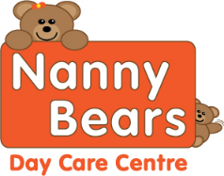 **V- Vegan DF- Dairy Free Nanny Bears Nursery Menu** 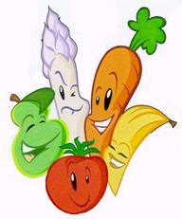

|  |  |  |  |  |  |
| --- | --- | --- | --- | --- | --- |
| **Week One** | **Monday** | **Tuesday** | **Wednesday** | **Thursday** | **Friday** |
| **Breakfast** | Selection of Cereals, Toasts with Honey, Lemon Curd or Jam Water and Milk available all day | | | | |
| **Snack AM** | Bananas and Pear | bread sticks DF, V | Raspberries | Crackers with spread DF V | Various fruits |
| **Lunch** | Fusilli Tomato Pasta bake with mixed vegetables.    V, DF | Corned beef Pie with Vegetables DF  Vegetable and potato pie V | Creamy Chicken Curry and Rice with poppadom’s DF  Vegetable curry with Rice V | Homemade Mince and Dumplings with Mixed Vegetables DF  Quorn mince for V | Fish Fingers, wedges and Peas  Veggie Sticks V DF |
| **Dessert** | Banana optional Custard | Apple Crumble with optional Custard | Mixed Berry pie with optional custard | Lemon Sponge with optional custard | Jelly and Fruit |
| **Snack PM** | Blueberries | Oranges and Bananas | Carrot and cucumber sticks | Mixed fruit | Pepper and cucumber Sticks |
| **Tea** | Carrot and Coriander V DF with wholemeal bread roll | Waffles and cheese DF,V | Selection of Sandwiches DF  V option spread | Chicken noodles DF  V noodles | Jacket potatoes with tuna and cucumber sticks DF |
| **Dessert** | Sponge Cake | Flavoured Ice cream | Chocolate Mouse | Granola and Banana with Plain Yogurt | Cookie DF,V option |

Although our food is prepared with care, due to handling allergens in our kitchen. We cannot guarantee it will be allergen free, even after the ingredients have been removed on request

All desserts for Vegan, Diary Free and other preferenaces are swapped for an alternative option

For Individual dietary please ask a member of staff for further information. Babies under 1 are given softer healthy options for snacks