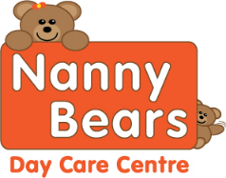**V=Vegan DF = Diary Free Nanny Bears Nursery Week Menu 3** 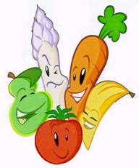

|  |  |  |  |  |  |
| --- | --- | --- | --- | --- | --- |
| **Week Three** | **Monday** | **Tuesday** | **Wednesday** | **Thursday** | **Friday** |
| **Breakfast** | Selection of Cereals, Toasts with Honey, Lemon Curd or Jam Water and Milk available all day | | | | |
| **Snack AM** | Pear and Apple | Melon Slices | Cheese and Tomatoes | Bread Sticks | Pears and Bananas |
| **Lunch** | Roast Chicken Dinner with Mash, mixed vegetables DF  Roast Vegetables V | Shepherd’s Pie with Vegetables and Gravy  Quorn mince V | Chicken Casserole and Vegetables DF  Vegetable Casserole V | Spaghetti Bolognaise with vegetables DF  Quron mince V | Fish cakes, potato croquettes and mushy peas  Veggie Burgers V, DF |
| **Dessert** | Jam Roly Poly with optional Custard | Apple pie with optional custard | Rice Pudding with Strawberry | Ginger Cake with optional custard | Swiss Roll |
| **Snacks PM** | Oat Cakes | nectarines | orange and apple | Cucumber sticks | Carrot Sticks |
| **Tea** | Pizza and Beans  Vegan Pizza DF | Veggie sticks and beans DF,V | Red lentil soup with a crusty roll DF,V | Assorted Wraps, DF  V spread | Tomato, basil with penne pasta |
| **Dessert** | Mixed Fruit Salad | Homemade Fruit Jam Tarts | Fruit yogurt | Flap jack slice | Peaches and Cream |

Although our food is prepared with care, due to handling allergens in our kitchen. We cannot guarantee it will be allergen free, even after the ingredients have been removed on request

All desserts for Vegan, Diary Free and other preferenaces are swapped for an alternative option

For Individual dietary please ask a member of staff for further information. Babies under 1 are given softer healthy options for snacks