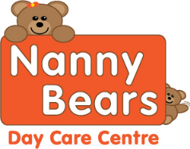**DF = Diary Free V=Vegan option Nanny Bears Nursery Week 2 Menu** 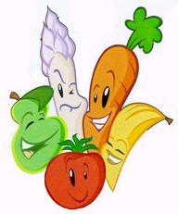

|  |  |  |  |  |  |
| --- | --- | --- | --- | --- | --- |
| **Week Two** | **Monday** | **Tuesday** | **Wednesday** | **Thursday** | **Friday** |
| **Breakfast** | Selection of Cereals, Toasts with Honey, Lemon Curd or Jam Water and Milk available all day | | | | |
| **Snack AM** | Pineapple | Rice Cakes | Apple | Cucumber and Tomatoes | Oranges and Pears |
| **Lunch** | Chicken and Vegetable Stir-Fry with noodles DF  Vegetable Stir Fry with noodles V | Homemade Lasagne with mixed vegetables  Vegetable Pasta Bake V DF | Homemade Stew with Yorkshire puddings and seasonal vegetables  Mixed vegetable stew and potatoes V DF | Cheesey, Bean Potato pie with mixed vegetables optional gravy  Potato and Bean pie V DF | Fish, Potatoes and Vegetables  Plant based burger V DF |
| **Dessert** | Fruit Cocktail with optional cream | Sponge with optional Custard | Flavoured Mouse | Rhubarb Crumble with optional custard | Rice Pudding |
| **Snacks PM** | Apple and Banana | Pepper Sticks | Strawberries | Mango slices | Kiwi |
| **Tea** | Jacket potato with  Beans V,DF | Egg Mayonnaise Sandwiches  V, DF Option spread | Spaghetti with toast fingers | Tuna Pasta with cucumber and sweetcorn | Vegetable soup served with a bread roll DF,V |
| **Dessert** | Mini Chocolate Roll | Raspberries and plain yogurt | Short Bread | Jelly | Fairy Cakes |

Although our food is prepared with care, due to handling allergens in our kitchen. We cannot guarantee it will be allergen free, even after the ingredients have been removed on request

All desserts for Vegan, Diary Free and other preferenaces are swapped for an alternative option

For Individual dietary please ask a member of staff for further information. Babies under 1 are given softer healthy options for snacks